Directions to the new showground

Warren Row Road, Knowl Hill, Maidenhead, RG10 9YT
From Maidenhead direction take the A4 towards Reading. As you enter Knowl Hill, take a right hand turn up Warren Row Road.

From Reading direction take the A4 towards Maidenhead. Just past the Royal Oak pub in Knowl Hill, take a left hand turn up Warren Row Road.

The Road is signposted towards Warren Row and Cockpole Green. Drive past the Showground on your right, and take the first right hand turn into the entrance.

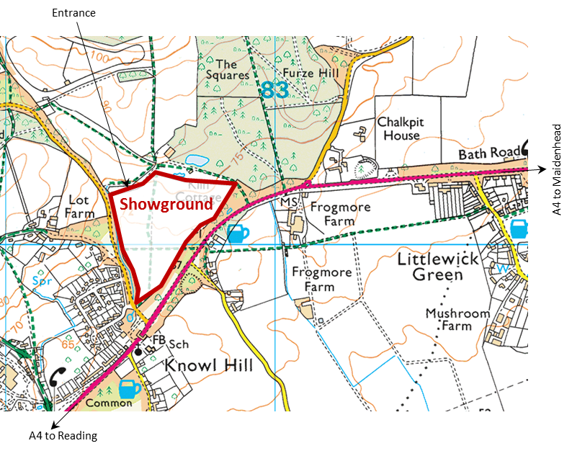

Please bring your own water for your horses, ponies and dogs.

Please ensure all your rubbish is taken home.

Thank you.

Littlewick Green Show Society
President: Mrs J. Distin

LITTLEWICK HORSE SHOW
2016

Bank Holiday Monday
29th August 2016

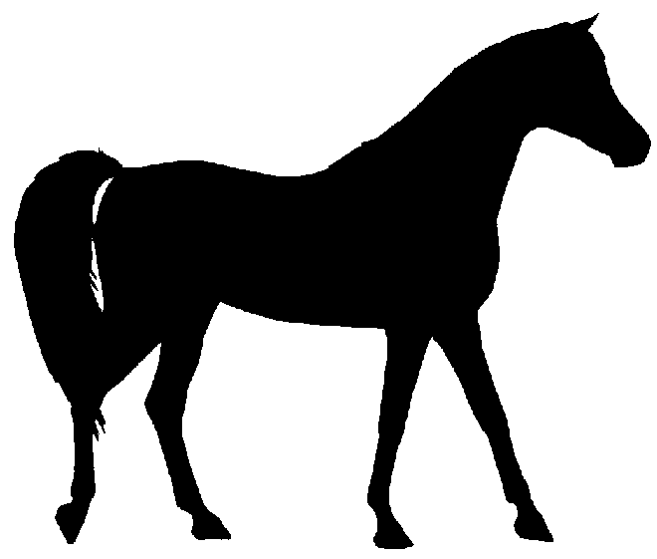
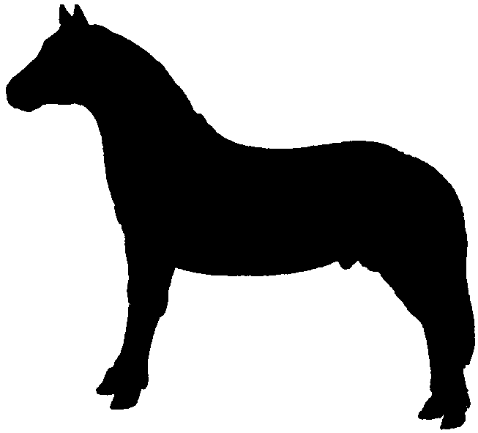

★ NEW LOCATION 
Warren Row Road, Knowl Hill, Maidenhead
Postcode: RG10 9YT

www.littlewickshow.co.uk

Entries to: Show Secretary
Joydens, Manor Road, Maidenhead, Berks, SL6 2QG
Email littlewickhorseshow@hotmail.co.uk
Telephone 07766 542500

Organised by the
Littlewick Horse Show Committee:
Jill Oseman, Pam Teasdale,
Pam Swift, and Jo Burton

Entry Fees

Jumping Classes: £10.00 each
Pairs Jumping: £15.00 per pair
Clear Round: £5.00 (at the ring side)
Showing Classes: £7.00 each
Gymkhana: £1.00 each (on the day)
First aid £3 per rider/handler

Entries on the day: £2.50 extra on each entry except for gymkhana
and clear round where entries are on the day.

Cups presented:

Class 4: Brookhart Cup
Class 6: Committee Trophy
Class 8: The Vigilante Challenge Cup
Class 16: MacBride Cup
Class 30: Best Utility Pony Challenge Cup
Class 34: Bunce Cup
Class 36: Cada Toys Challenge Trophy
Class 37: Battledore Challenge Trophy

A plaque will be awarded to the winner of each class except Gymkhana.
Rosettes to 8th place.
Gymkhana rosettes to 4th place.

Catering
All day on-site catering.

Please note: All horse boxes and trailers plus their occupants will gain free access to the show. However, anyone arriving by car or on foot must pay the admission fee, even if accompanying a horsebox.

Information and Show Rules

1. The decision of the organisers, judges & stewards will be final.
2. Although every effort is made to run the show to time, entry fees cannot be refunded when classes coincide.
3. The Committee reserves the right to move classes and/or rings as necessary.
4. Classes may be split or amalgamated at the judge’s discretion depending upon entries.
5. All jumping classes will be judged with reference to the rules of the BSJA. NOTE: riders are prohibited from remounting after a fall.
6. Entries in all classes will be strictly limited. Please note: classes may become full prior to the show date. Only if classes are not full will entries on the showground be accepted. Entries on the day £2.50 extra.
7. Rosettes will be awarded to 8th place, excluding gymkhana where rosettes will be given to 4th place.
8. LHSC, LGSS, the landowner, organisers and officials will accept no responsibility for any damage or injury that may occur to horse, rider, spectator or vehicle howsoever caused.
9. Correct riding attire and hard hats must be worn at all times whilst mounted anywhere on the showground. Acceptable hard hat standards are: PAS 015: 1998 or 2011 with BSI Kitemark, VG1 01.040: 2014-12 with BSI Kitemark, ASTM F1163: 2004a or 04a with SEI Mark, SNELL E2001, AS/NZS 3838: 2006 with SAI Global Mark. Exceptions can be made for those entering Class 15 in traditional dress, a disclaimer must be signed in the Secretary’s tent.
10. All horses and ponies must be aged 4 years and over except in the in-hand classes.
11. Entry fees will only be refunded on production of a vet’s or doctor’s certificate.
12. First Aid will be provided on the show ground. The first aid charge of £3.00 applies equally to riders and handlers.
13. All enquiries should be made to the Horse Section Secretary’s tent.
14. All dogs must be kept on a lead and under control at all times.
15. Enquiries: Joanna Burton on 07766 542500.

Ring Three

Starts 09:00hrs
Please state breed on entry form for Mountain & Moorland classes.

Class 27: Mountain & Moorland: In Hand - Small Breeds
Welsh Sec A & B, Shetland, Dartmoor, Exmoor.
Open to registered and unregistered breeds of any age or sex.

Class 28: Mountain & Moorland: In Hand - Large Breeds
Welsh Sec C & D, Dales, Connemara, New Forest, Fell, Highland.
Open to registered and unregistered breeds of any age or sex.

Class 29: Lead Rein
Open to any rider/horse/pony. Combination may not enter Class 9 or 11.

Not before 11:00hrs

Class 30: Family Mount
Horse or pony suitable for all members of the family. Snaffle bridles only. No boots, bandages or martingales. Cup: Best Utility Pony Challenge Cup

Class 31: Veterans In Hand
Horses and ponies 17 years and over.

Not before 12:30hrs

Class 32: Mountain & Moorland: Ridden - Small Breeds
Welsh Sec A & B, Shetland, Dartmoor, Exmoor.
Open to registered and unregistered ponies of any age or sex.

Class 33: Mountain & Moorland: Ridden - Large Breeds
Welsh Sec C & D, Dales, Connemara, New Forest, Fell, Highland.
Open to registered and unregistered breeds of any age or sex.

Class 34: Ridden Veteran
Horses/ponies 17 years old and over. No martingales or bandages/boots.
Cup: Bunce Cup

Class 35: Pairs
To be judged on compatibility and a synchronised show.

Class 36: Riding Club Horse
For horses exceeding 14.2hh. Judged on suitability for Riding Club activities. Snaffle bridles only. No boots, bandages or martingales. May be required to jump a small fence.
Cup: Cada Toys Challenge Trophy

Class 37: Riding Horse
For horses 15.2hh and over. Horses will not be required to jump.
Cup: Battledore Challenge Trophy
Main Ring
Starts 08:30hrs

Clear Round Jumping
Jumps up to 2ft. Entries at ringside £5. No pre-payment taken.

Starts 09:00hrs
Jackets must be worn

Class 1: Minimus Jumping
Combination of rider and horse/pony not to have been placed 1st, 2nd or 3rd in any jumping event. Jumps approximately 2ft in the first round.
Riders entering this class may not take part in any other main ring classes, apart from classes 2 and 3. Cup for best turned out pony and rider.

Class 2: Novice Jumping (Two Phase)
Horses/ponies not to have won more than £10 in total in jumping classes. Jumps approximately 2ft 3ins in the first round.

Class 3: Horse and Hound
Horses/ponies/handlers & dogs to jump in relay against the clock.
Fences up to 1ft 6ins. Dogs may compete on or off the lead.

To follow, for 30 minutes

Clear Round Jumping
Jumps up to 2ft 6ins. Entries at ringside £5. No pre-payment taken.

Class 4: Local Jumping (Two Phase)
Horses/ponies kept within a 15 mile radius of the showground.
Jumps approximately 2ft 6ins in the first round.
Cup: Brookhart Cup

Class 5: Pairs Relay
Jumps approximately 2ft 6ins.
Class judged on time (no jump off).

Class 6: Open Intermediate Jumping (Two Phase)
Jumps approximately 2ft 9ins in the first round.
Cup: Committee trophy

Two Phase:
If the competitor completes a clear round they will continue to jump off against the clock immediately.
Ring Two

Starts 09:00hrs

Class 7: Best Condition
In Hand. Horses and ponies of any size or age.

Class 8: Tack and Turnout
Section A Show turnout (must be plaited)
Section B Hacking turnout
Cup: The Vigilante Challenge Cup

Class 9: First Pony
Ponies any height. Children 10 years and under on date of show. To be judged on condition, presentation, turnout and character of pony. Children entering this class may not enter Classes 11 or 29.

Class 10: Coloured In Hand
Piebald, skewbald, tri-colour or spotted. Open to horses/ponies any height or sex

Not before 11:00hrs

Class 11: Second Pony
Ponies any height, suitable for all pony club activities.
Children 10 years and over on date of show.
To be judged on condition, presentation, turnout and rider.
Competitors may not enter Classes 9 or 29.

Class 12: Ridden Cob
Open to horses 14.2hh (148cm) or over. Horse may be ridden by judge.
Horses need not be hogged.

Class 13: Ridden Coloured
Piebald, skewbald, tri-colour or spotted. Open to horses/ponies any height or sex.

Not before 13:00hrs

Class 14: Fancy Dress
Open to riders of any age. Horses/ponies may be ridden.
Riders must wear standard hats and suitable riding boots.
Equines must wear saddles.

Class 15: Foreign Breeds Ridden
Open to any foreign breed except warmbloods.
Traditional (see rule 9) or non-traditional dress.
Class will be split at judge’s discretion. Please state breed on entry form.
Ring Two continued

Class 16: Handy Pony
Open to any rider/horse combination.
To complete a course of obstacles and tasks,
to include one or more very small jumps.
Cup: The MacBride Cup

Not before 15:00hrs

Gymkhana

All entries on the day from the Secretary’s tent.

£1.00 per class.

Minimus section

Children in this section must wear approved riding hats (see rule 9) and footwear but need not wear show jackets.
All riders MUST be led.
Competitors entering this section may not compete in any Open Gymkhana classes.

Class 17: Egg and spoon race
Class 18: Round the world
Class 19: Potato race
Class 20: Musical cups

Open section

Class 21: Egg and spoon race
Class 22: Potato race
Class 23: Canter, trot, walk
Class 24: Bucket elimination
Class 25: Musical cups
Class 26: Consolation race

Millwheel Tack Shop & G.G. Feeds

Our equipment and feed always comes first...

- Top brands.
- Horse feed and bedding (including delivery service).
- Extended second-hand department, offering everything from jodhpur boots to saddles.
- Master saddler who will fit any saddle whether new or second-hand and take on any saddlery or tack repairs.
- Rugs washed and repaired
- Clippers serviced/blades sharpened.
And all at very competitive prices

Tel: 01344 486059 Mob: 07973 637629
saradodwell@outlook.com
Millwheel Tack Shop & G.G. Feeds
Moss End Garden Centre
Maidenhead Road
Warfield
Berkshire RG42 6EJ

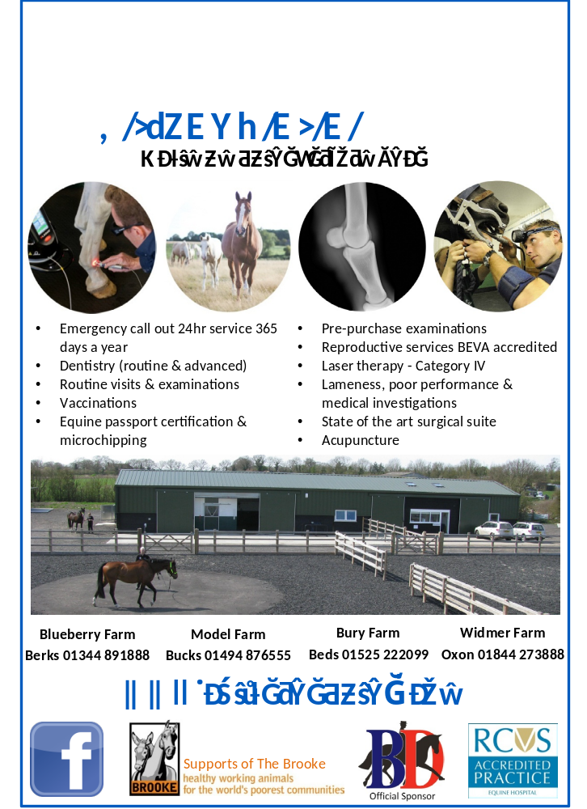
Horse Show
to be held at
Littlewick Show, Warren Row Road, Knowl Hill, Maidenhead, RG10 9YT
on Bank Holiday Monday, 29th August 2016

Entries to: Entries Secretary, Joydens,
Manor Road, Maidenhead, Berks, SL6 2QG

Name:

Address:

Post code:

Telephone: |  | Mobile: |  | Email:
Contact in case of emergency:

I agree to abide by the rules and conditions as set out in the schedule (must be signed by a parent or guardian if under the age of 18)

Signature:

Class | Name of rider/handler |  | Name of horse |  | Fee
 |  |  | Total |  | £
 |  |  | First aid per rider/handler £3 |  | £
 |  |  | Total |  | £
Classes 15, 27, 28, 32 and 33: Pony’s Breed:

Cheques to be made payable to: ‘Littlewick Horse Show Committee’.

Please note: All horse boxes and trailers, plus their occupants will gain free access to the show. However, anyone arriving by car or by foot must pay the admission fee, even if accompanying a horsebox.

